**Top 15 Linux Commands**

1. Sudo su

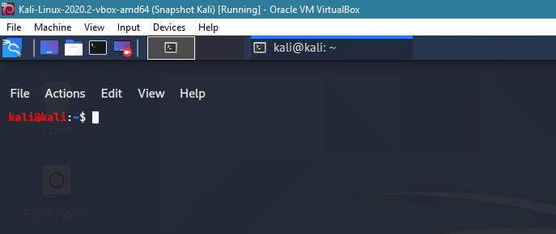Super user (Type password, which will not display

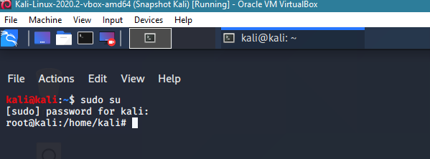Root user

1. Mkdir

Make directory

(Basically creating a folder)

1. Cd

Change directory

Note: cd.. takes you back to desktop or the root folder

1. Echo

Allows you to write something into a file

Example: echo “HelloWorld” > file1

1. Nano

Nano is an editor, to edit a file, control x to save and get out of nano editor

1. Pwd

Print working directory

1. Ls

Lists all the folders/ files with details

Ls-l = Lists the file permission

1. Rmdir

Rmdir removes directory

1. Cp

Copy file from one file to another (cp file2 file3) basically copying file 2 to file 3

1. Mv

Moving file into another file, also renames a file/ directory

1. History

All the command that has been used so far into the system

1. Grep

Grep is used to find similar expressions, search for a file or similarly named multiple files; you can use ls with grep to find specific name in the list

1. Cat

Cat command is only used for the files, to look into the file

1. Rm

Rm* removes all the files, rm removes only the specific file with nothing in it; rm-r (recursive) deletes everything in the folder, the content of the file

1. Man

Manual page for any command and all the parameters that command can use